for examining the relationship between the birth weight of a baby and the number of siblings of the baby? (Assume there are a few hundred observations)

We have two quantitative variables, however one of them is discrete (# of siblings) meaning that a scatterplot is not the best choice. Same goes for the barplot?

Side-by-side boxplots (one boxplot for each number of siblings) would allow for comparisons. Same for the density curves (check slides/notebook for how these

would look like)

Trade off between a model that understands complex behavoirs, between predicting unseen data

HEAVY WORK

El hecho que no haga todo lo que queria, no es malo no tiene que verse cimo castigo sino como leccion y valorar lo que no ofunciono

DECISION TREE OF DEPTH 1 == LINEAR MODEL

## LECTURE 1:

 descriptive statistics for this data are the min, max, median (The center of the data values), and mean. For symmetric distributions, the median is directly in the middle

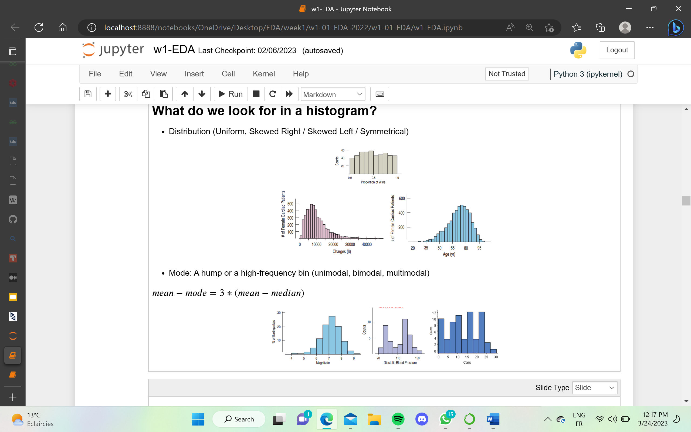

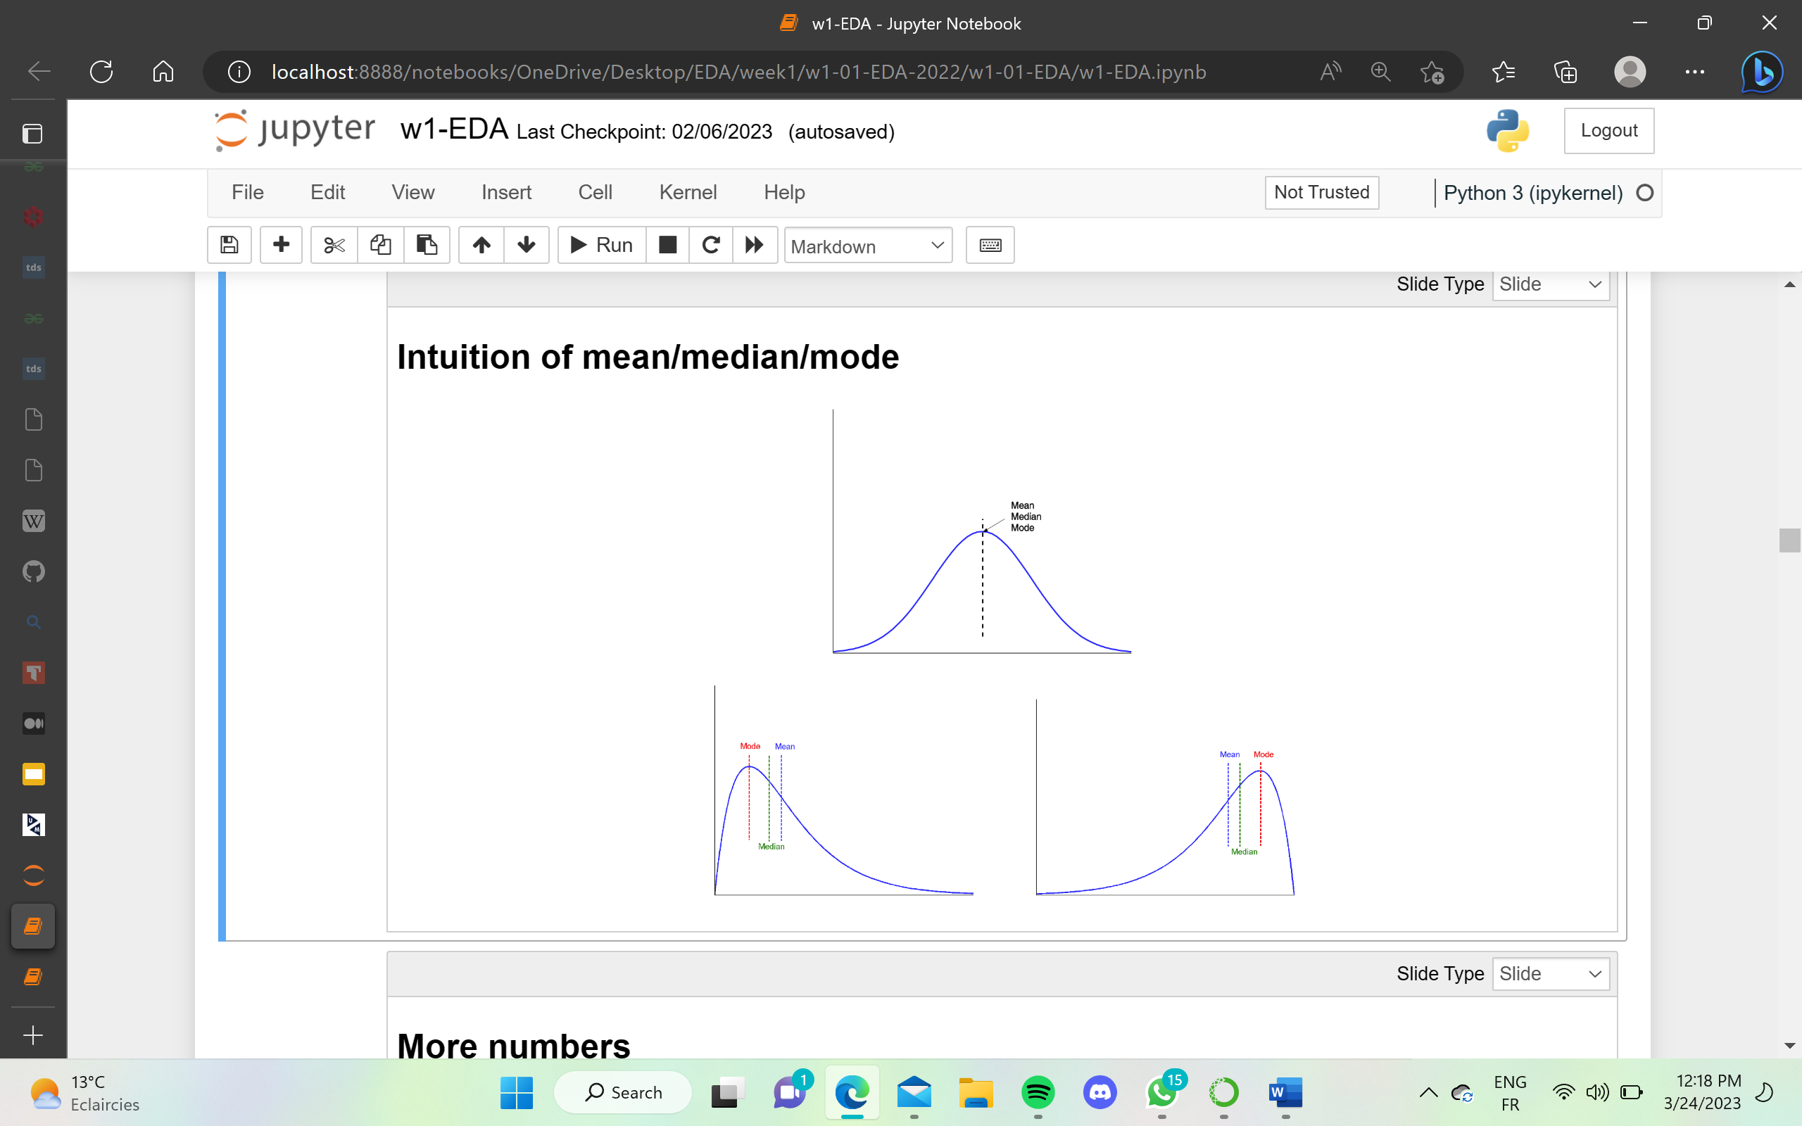 

**Quantiles:** describe what percentage of the observations in a sample have smaller value

Range, variance and standard deviation quantify the amount of variation or dispersion of a set of data values.

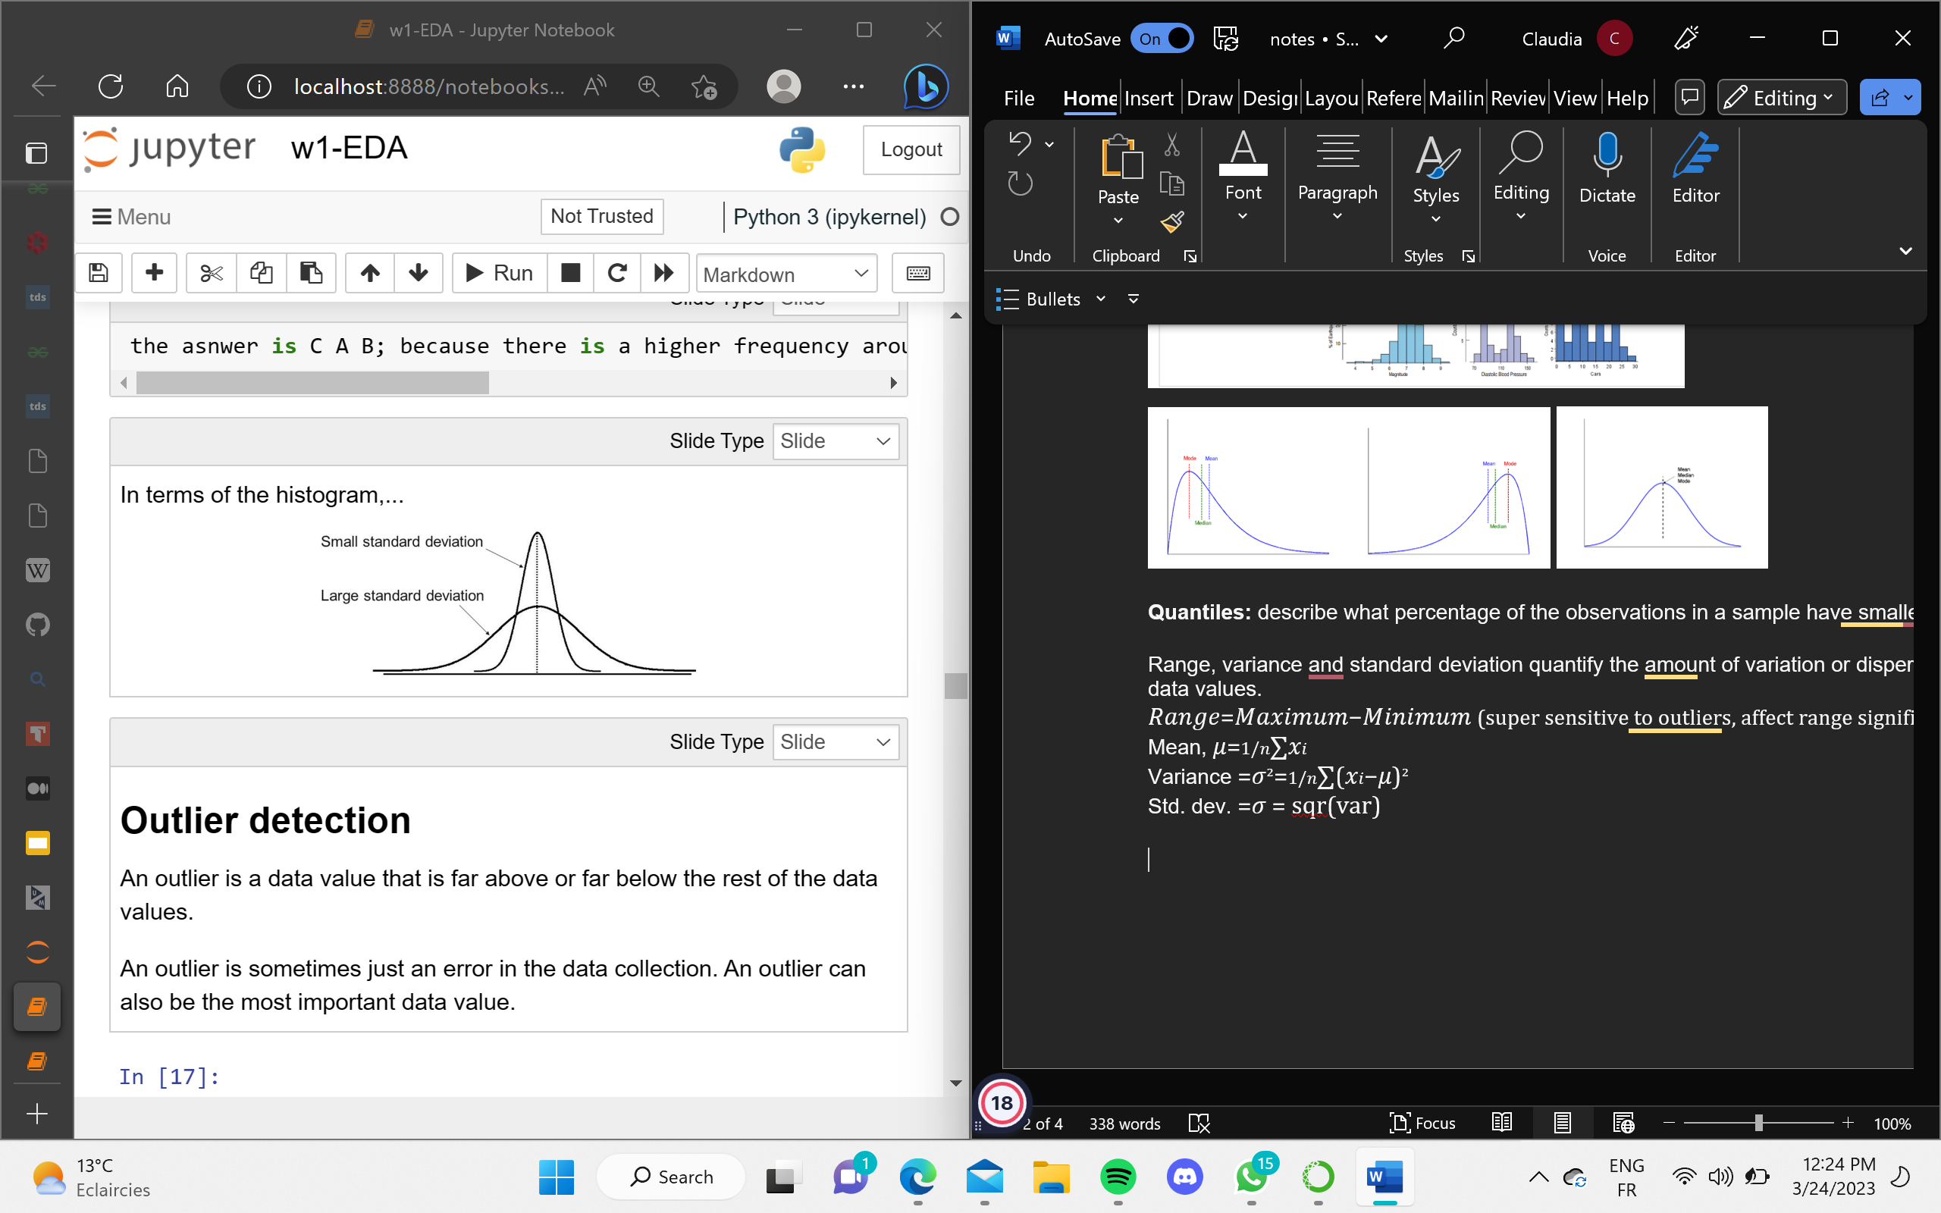

𝑅𝑎𝑛𝑔𝑒=𝑀𝑎𝑥𝑖𝑚𝑢𝑚−𝑀𝑖𝑛𝑖𝑚𝑢𝑚 (super sensitive to outliers, affect range significantly)

Mean, 𝜇=1/𝑛∑𝑥𝑖  
Variance =𝜎²=1/𝑛∑(𝑥𝑖−𝜇)²

Std. dev. =𝜎 = sqr(var)

Covariance and correlation measure of how much two variables change together. Vars need to be quantitative. Interchanging the axis doesn’t affeect corr, neither if you scale all together. Highly affected by outliers

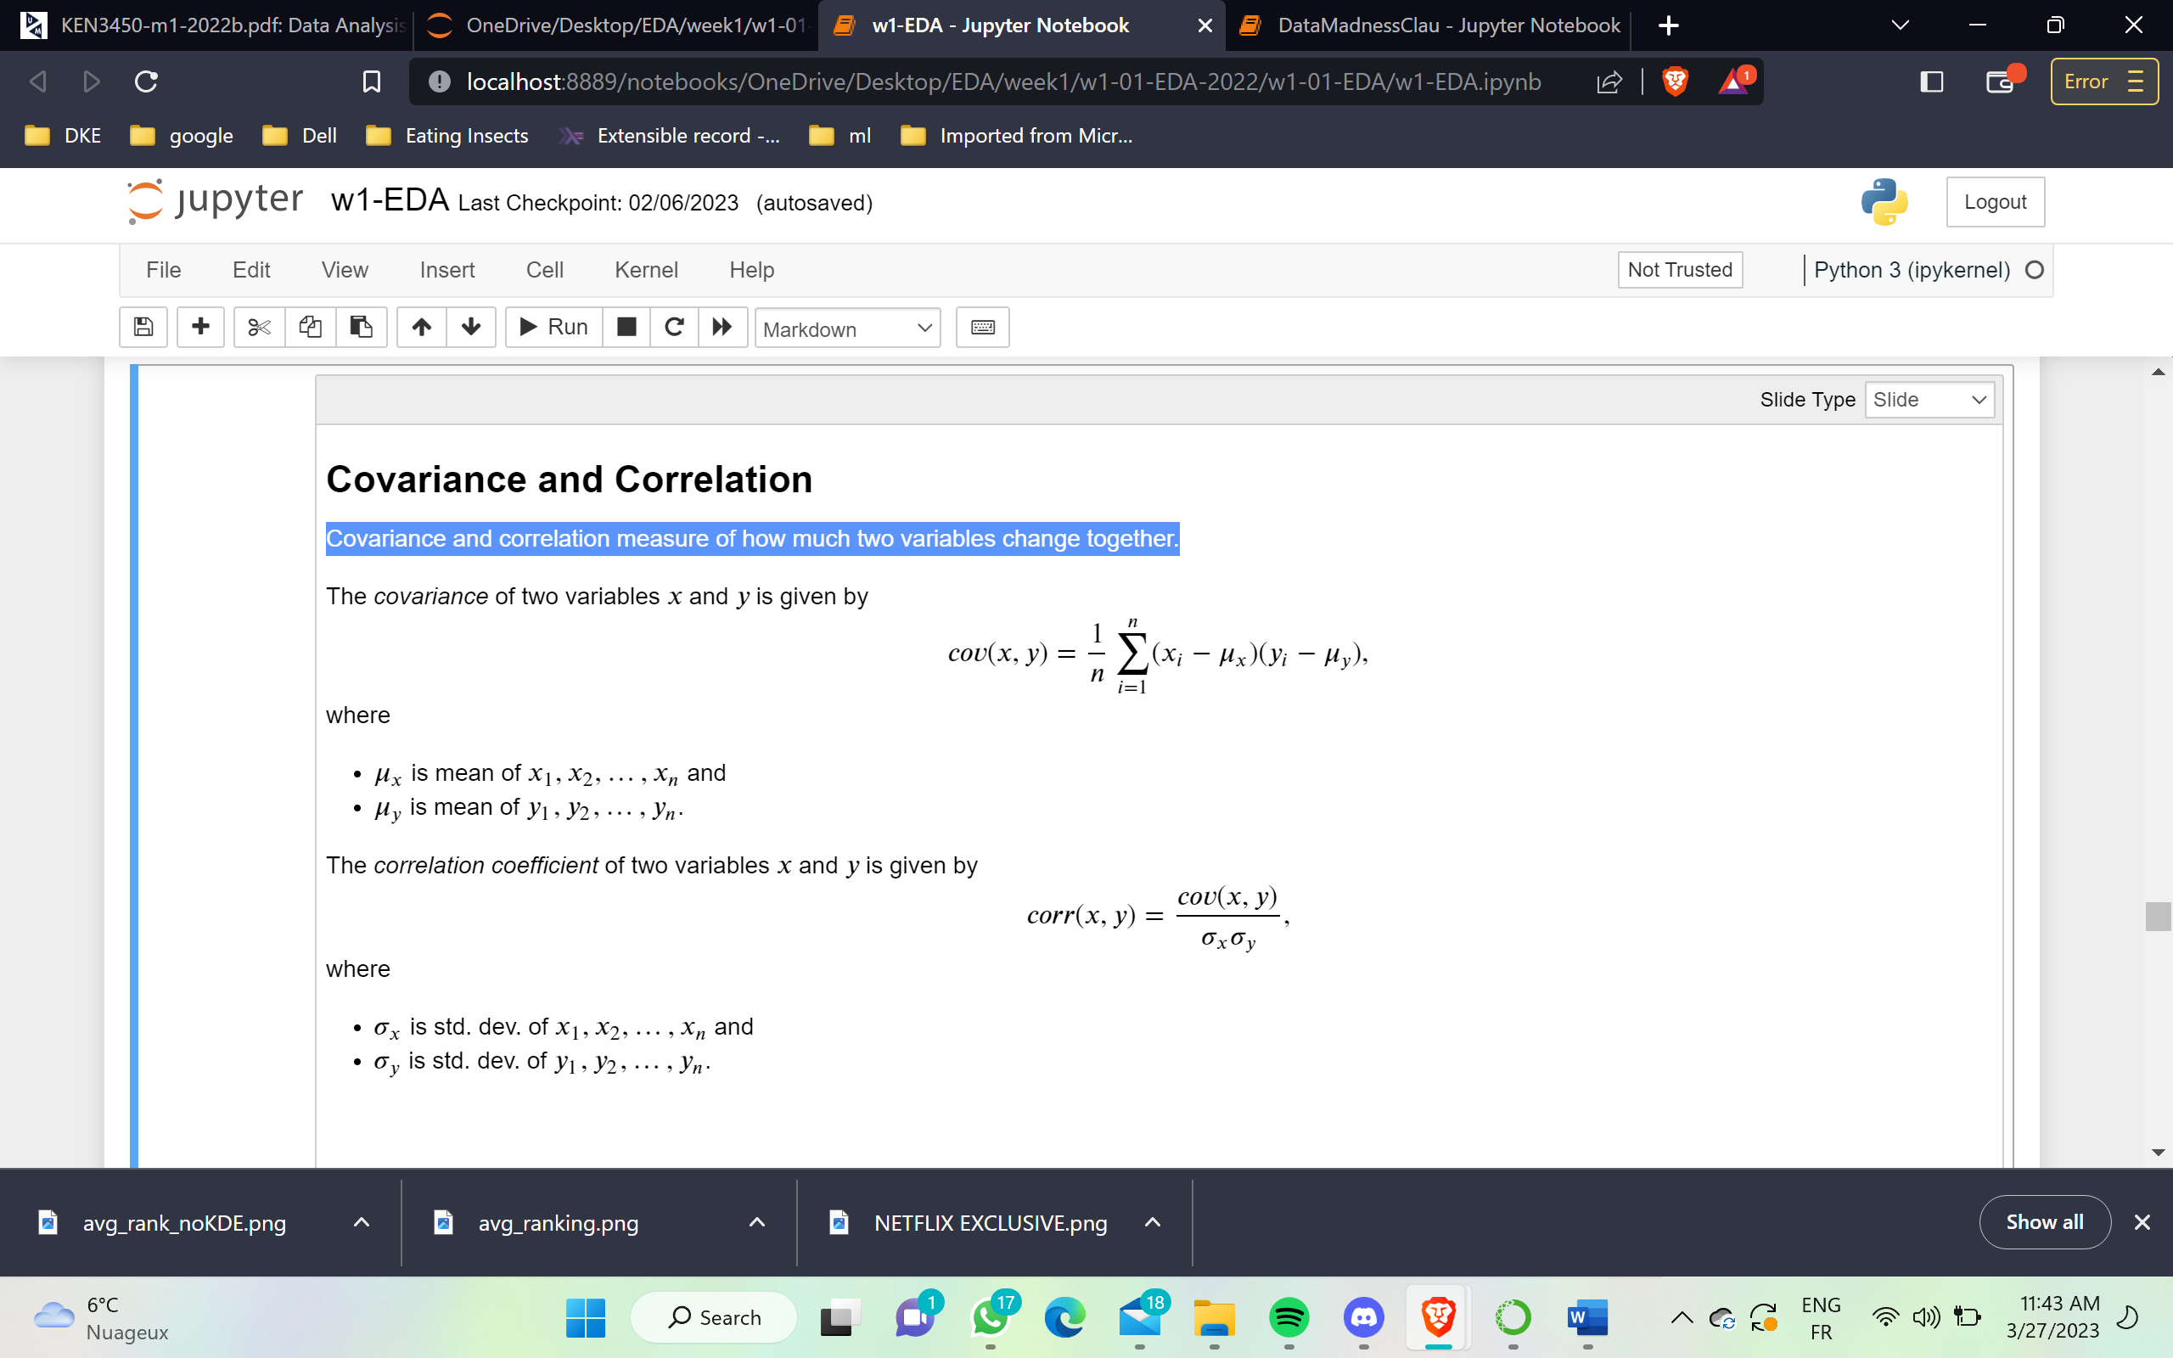

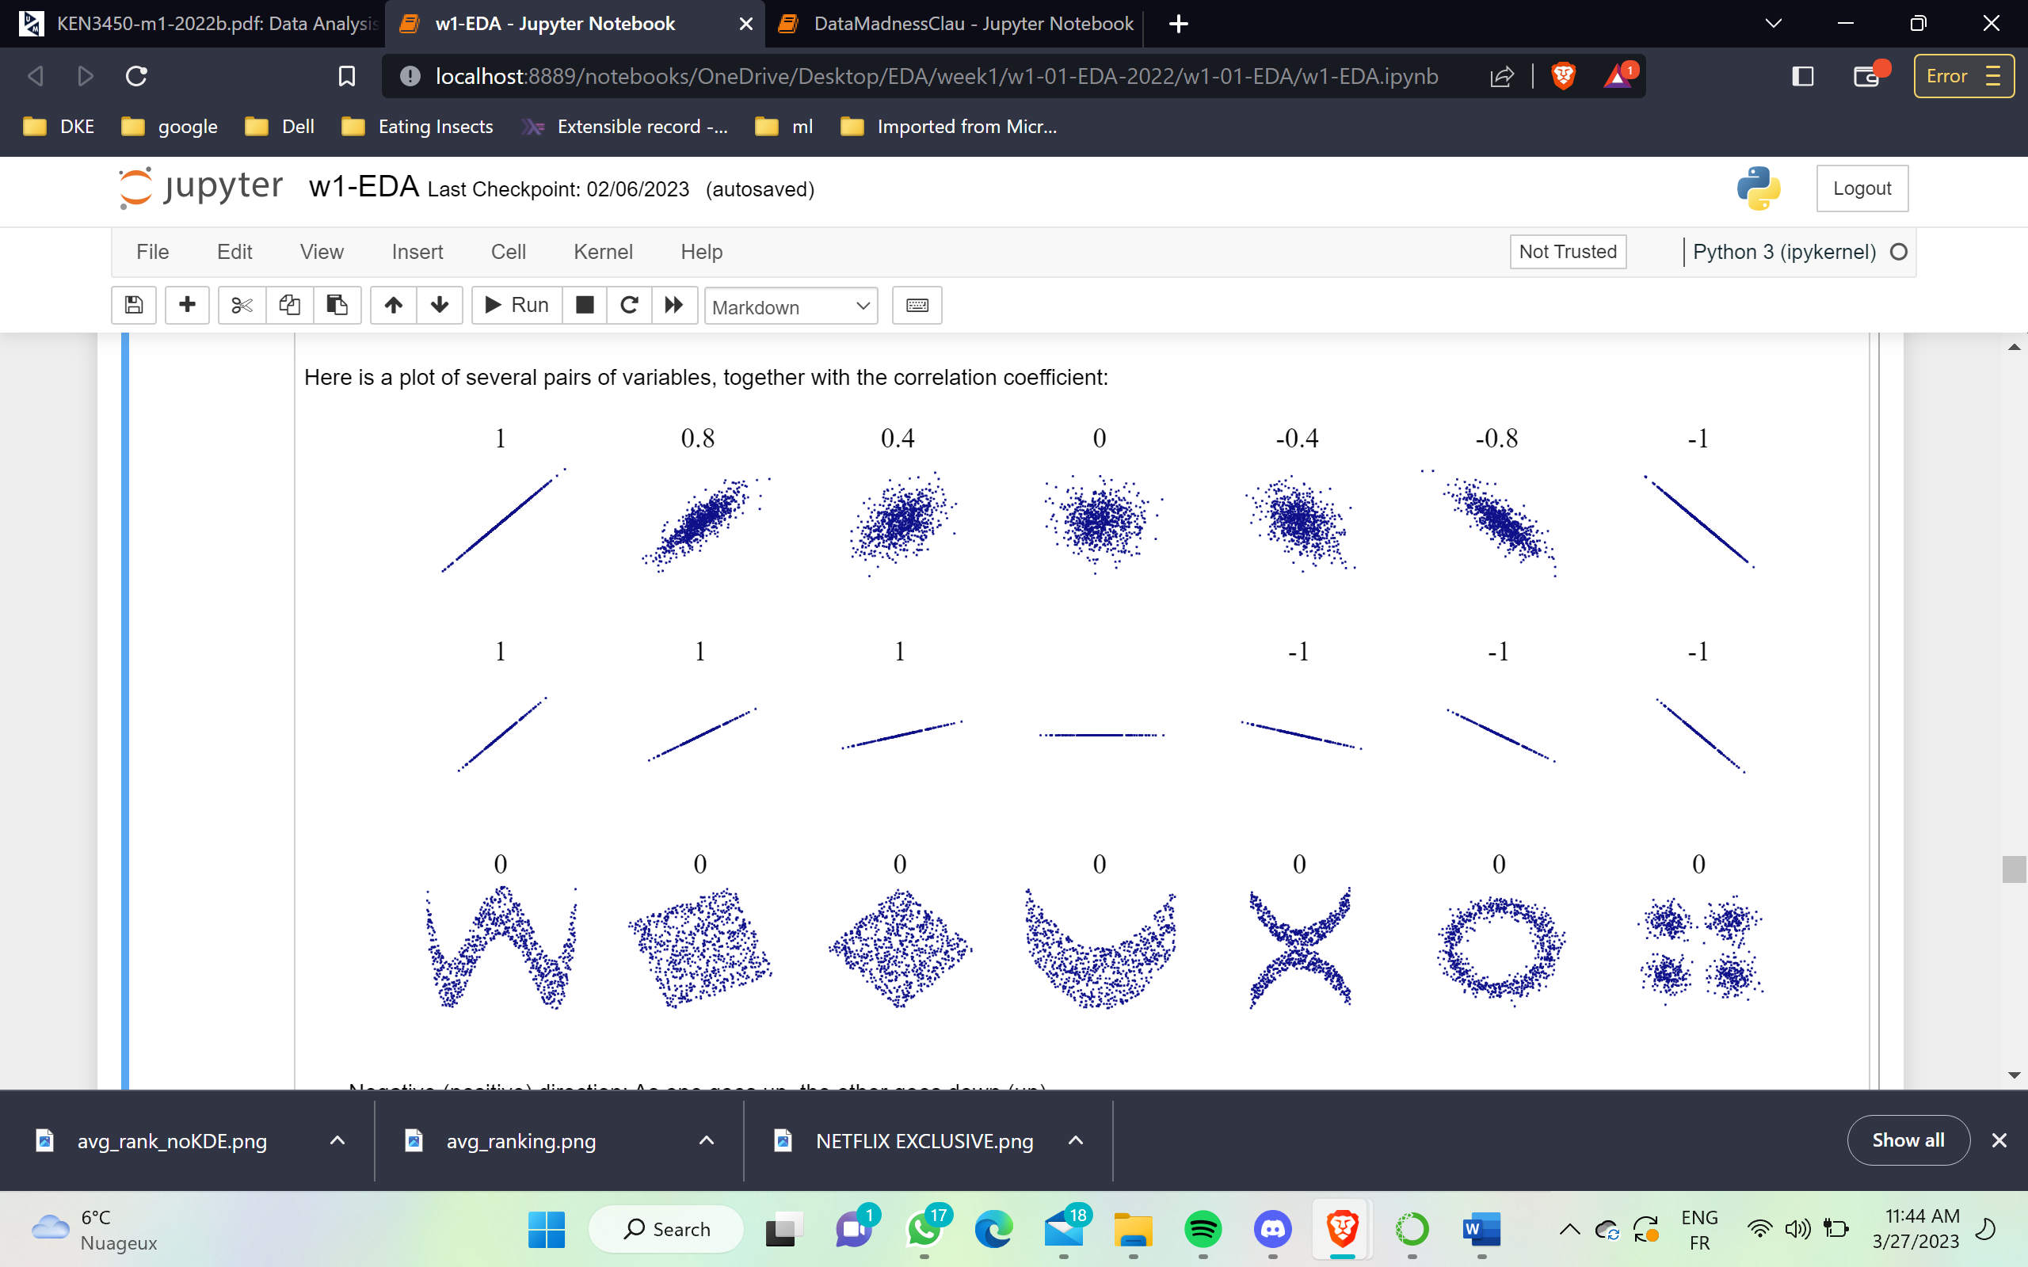

Negative (positive) direction: As one goes up, the other goes down (up). No direction means no relationship.Clear line means a clearly linear relationship. Dense line means a strong linear relationship. Extreme values (outliers) can also be found here!

-1<= corr <= 1

An outlier is a data value that is far above or far below the rest of the data values.It is sometimes just an error in the data collection. An outlier can also be the most important data value

Boxplot: The box shows the Interquartile Range (𝐼𝑄𝑅=𝑄3−𝑄1). The line inside the box shows the median. The dashed lines are called fences, outside the fences lie the outliers. whiskers that display the most extreme data values within the fences (Lower Fence = 𝑄1−1.5∗𝐼𝑄𝑅, Upper Fence = 𝑄3+1.5∗𝐼𝑄𝑅). This is done for every feature of DS

5 pint summary:

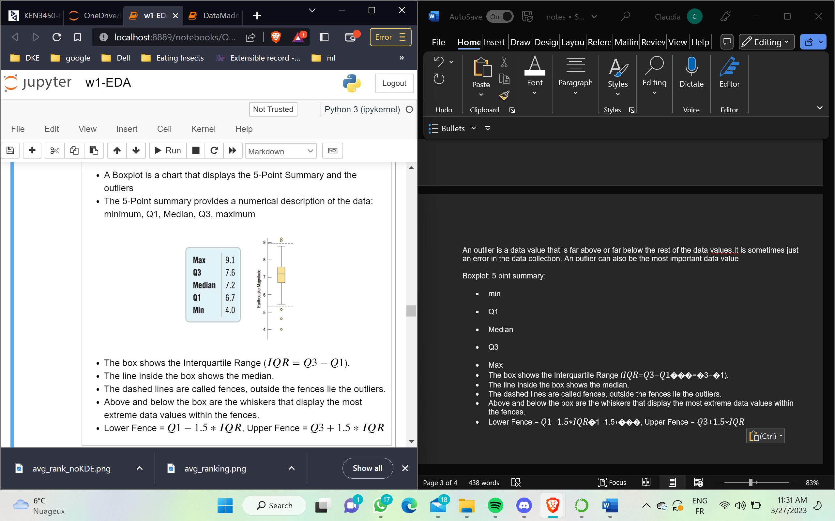

* min
* Q1
* Median
* Q3
* Max

Vars:

* **quantitative variables**: values are real number, continuous(e.g., length) or discrete (e.g., #cars)
* **categorical (or qualitative) variables**: values are discrete (e.g., year born, T/F). Can or NOT have an order associated. You cant use hists! Use frequency tables, bart charts or pie. Don’t compute numerical summaries

**Visualization:** help us to analyze and explore the data.  
• Identify hidden patterns and trends  
• Formulate/test hypotheses  
• Communicate any modeling results ( Present information and ideas, Provide evidence and support)  
• Determine the next step in analysis/modeling

AN effective visualization: graphical inftegrity, simple enough, sensible design, right display

Graphical integrity: show data variation andnot design variation, detailed labelling, be proportional and plot all data

Keep it simple: graphic effect prop.to numeric quantities

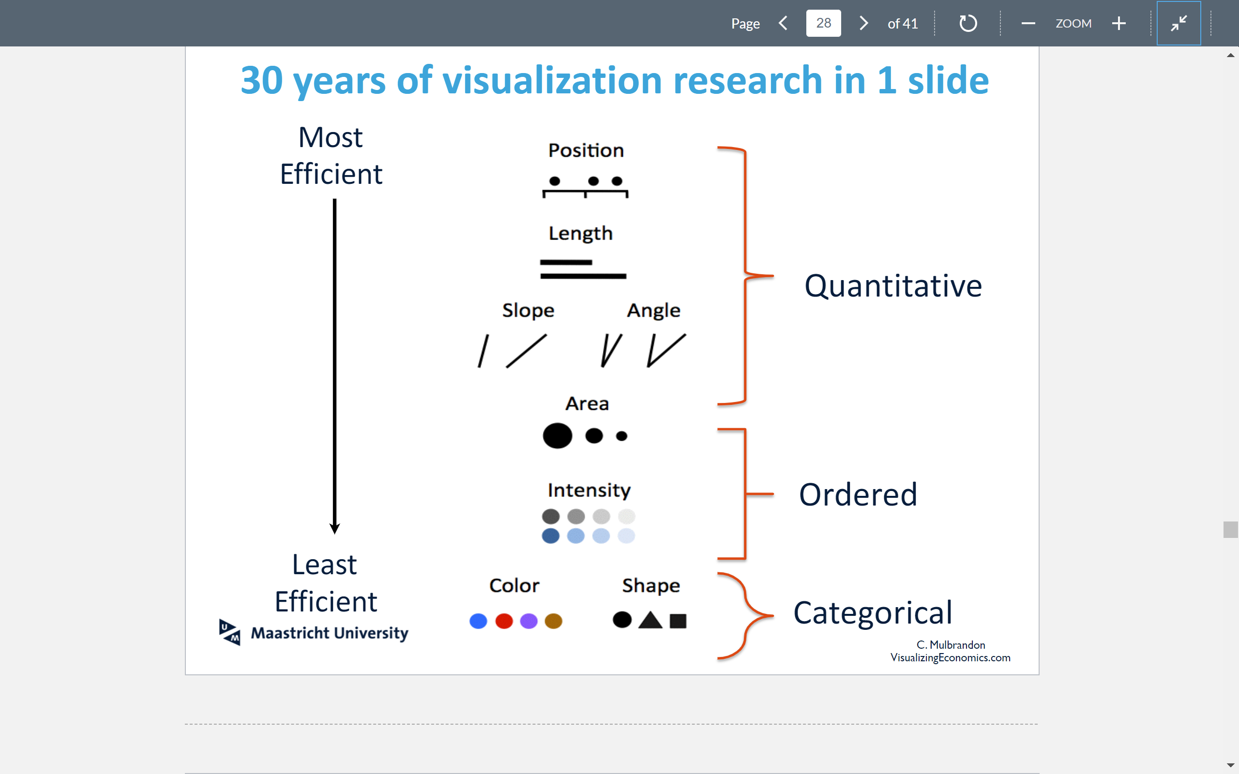

When histograms: choose appropriate bin width. Use a histogram to ensure that the mean and standard deviation really do describe the data.

Line plots are used for evolution or time, not much else!

Scatterplots exhibit the relationship between two variables. Used for detecting patterns, trends, relationships and extraordinary values

If you have time (continuous or discrete) consider stacked graphs

Avoid 3D in general

Pie charts are generally not a good idea, sometimes yes to represent a high percentage of categprical

Color-coding (when you want to add a categorical variable) or (light)3D (when you want to add a third quantitative variable) might work **, careful with red-green** Color blindness!  
• For quantitative variables: Do not use color • For ordinal data: Try varying luminance & saturation  
• For categorical data: Do not use more than 5-8 colors.

• Distribution: how a variable or variables in the dataset distribute over a range of possible values.  
• Relationship: how the values of multiple variables in thedataset relate  
• Composition: how the dataset breaks down into subgroups  
• Comparison: how trends in multiple variable or datasets compare



LECTURE 2:

Describe the steps in the sampling process  
- Why do we need to sample?  
- What it means for our sample to be biased?  
- How to prevent biases in your sample?  
• Explain the principles of probability sampling and how they form a basis for making statistical inferences from a sample to a population  
- What is a good sampling frame?  
• Identify the steps of conducting a hypothesis test  
• Calculate different hypothesis tests and interpret the results 3

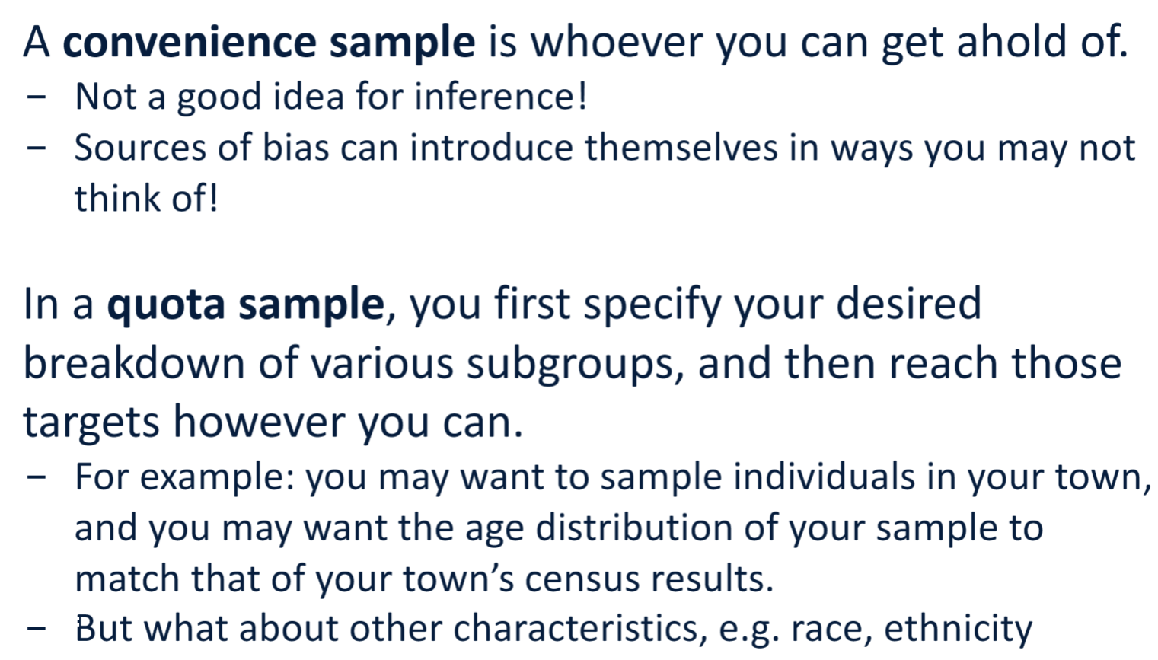

10 million participants. They sampled people who owned phones, subscribed to magazines,and went to country clubs, whoat the time were more affluent.These people tended to vote Republican (Alf Landon). Onlh 2.4 mil actually filled the survey. Another guypredicted the newspaper would do so and he just sampled those same individual (just 3k)



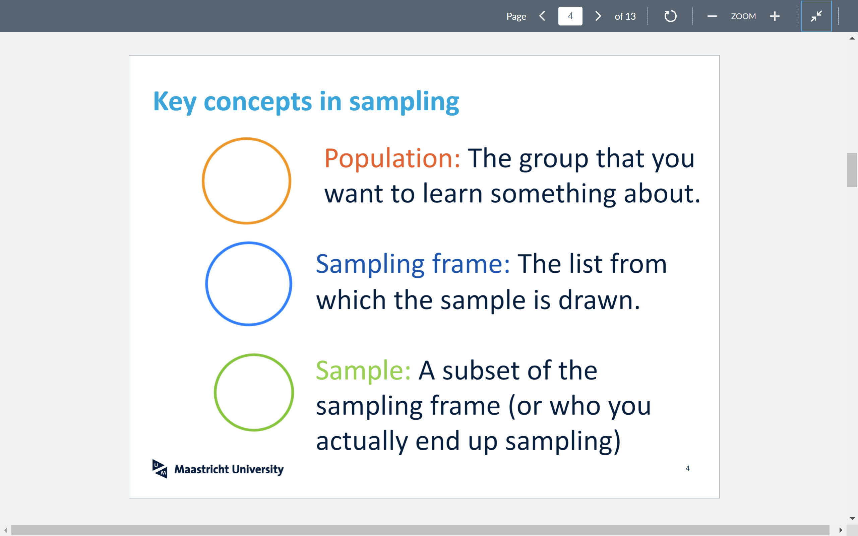

Achieve representative sample:

Selection Bias: Systematically excluding/favoring particular groups. How to avoid: Examine the sampling frame and the method of sampling

Response Bias: People don’t answer truthfully. ->Examine nature of questions and methods of survey

Non Response Bias: not always an answer; -> Keep your surveys short, and be persistent.

Descriptive statistics quantitatively describe or summarize features of a dataset.

Inferential statistics attempts to learn about the population from which the data was sampled. model the population as a probability distribution; deducing properties of an underlying probability distribution from sampled data

**An empirical distribution**  based on observational data, e.g. think about your answers to a poll. It shows us values and proportions.

**A probability distribution**would give us a model for how the sample is generated, e.g. think about what the polling of a student in class would be; empirical distributions show us "what it is" (or "was"), but probability distributions show us "what it could be".

**A random variable** is a variable that takes numerical values based on some probabilities. Ex outcome of fair dice.Their prob corresponds to the number possible of outcomes

Bernoulli and Binomial are discrete random vars ( 0, 1, ..n )

Bernoulli Dist: is the probability distribution of a random variable which takes the value 1 (success) with probability 𝑝 and the value 0(failure) with probability 𝑞=1−𝑝.If tails p!= 0.5 then its not a fair coin

* mean is p
* variance is p(1-p)

Binomial Dist: summarizes" the outcome of 𝑛 indepedent Bernoulli random variables (prob p ). We only keep track of how many heads/tails there were in total

* The mean is 𝑛𝑝
* The variance is 𝑛𝑝(1−𝑝)

Probability mass functions: probability that the variable takes each value ( similar to histogram.. not coincidence)

or a Bernoulli random variable, the probability mass function is given by

Prob(𝑋=𝑘)=𝑓(𝑘)={𝑝 if k=1 or 1-p if 𝑘=0

For a binomial random variable, the probability mass function is given by

𝑓(𝑘)=(𝑛 𝑘)𝑝^𝑘 (1−𝑝)^(𝑛−𝑘)., where (n k )= n! / (k!(n-k)!) , k heads of n flips

## Probability density functions: for continuous vars . The values are determined by their distr.

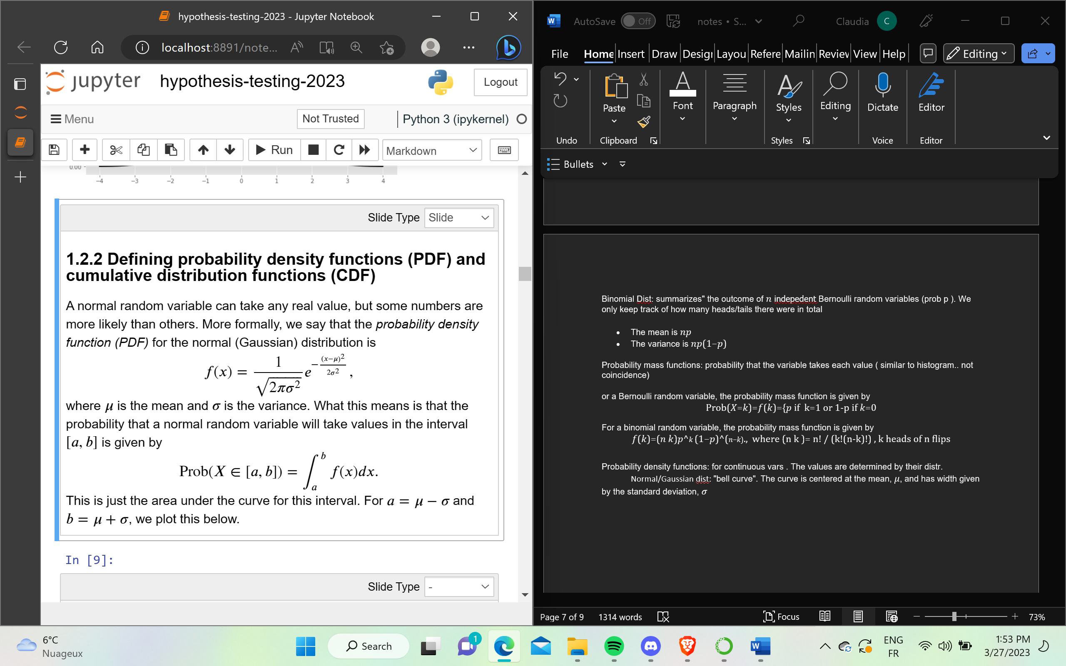

Normal/Gaussian dist: "bell curve". The curve is centered at the mean, 𝜇, and has width given by the standard deviation, 𝜎

Where if we integrate from -inf to +inf integral(f(x) ) = 1

Cumulatibve dist F(x) (CDF) is the integral from -inf to x, the values of var we are interested. Or from a < b = F(b) -F(a)

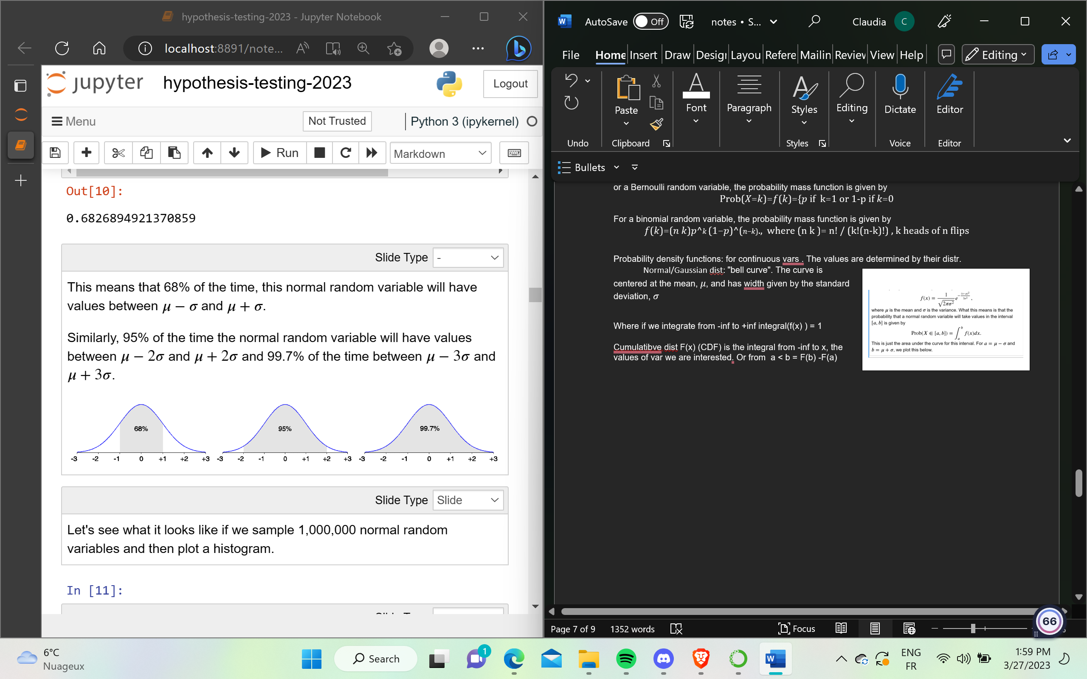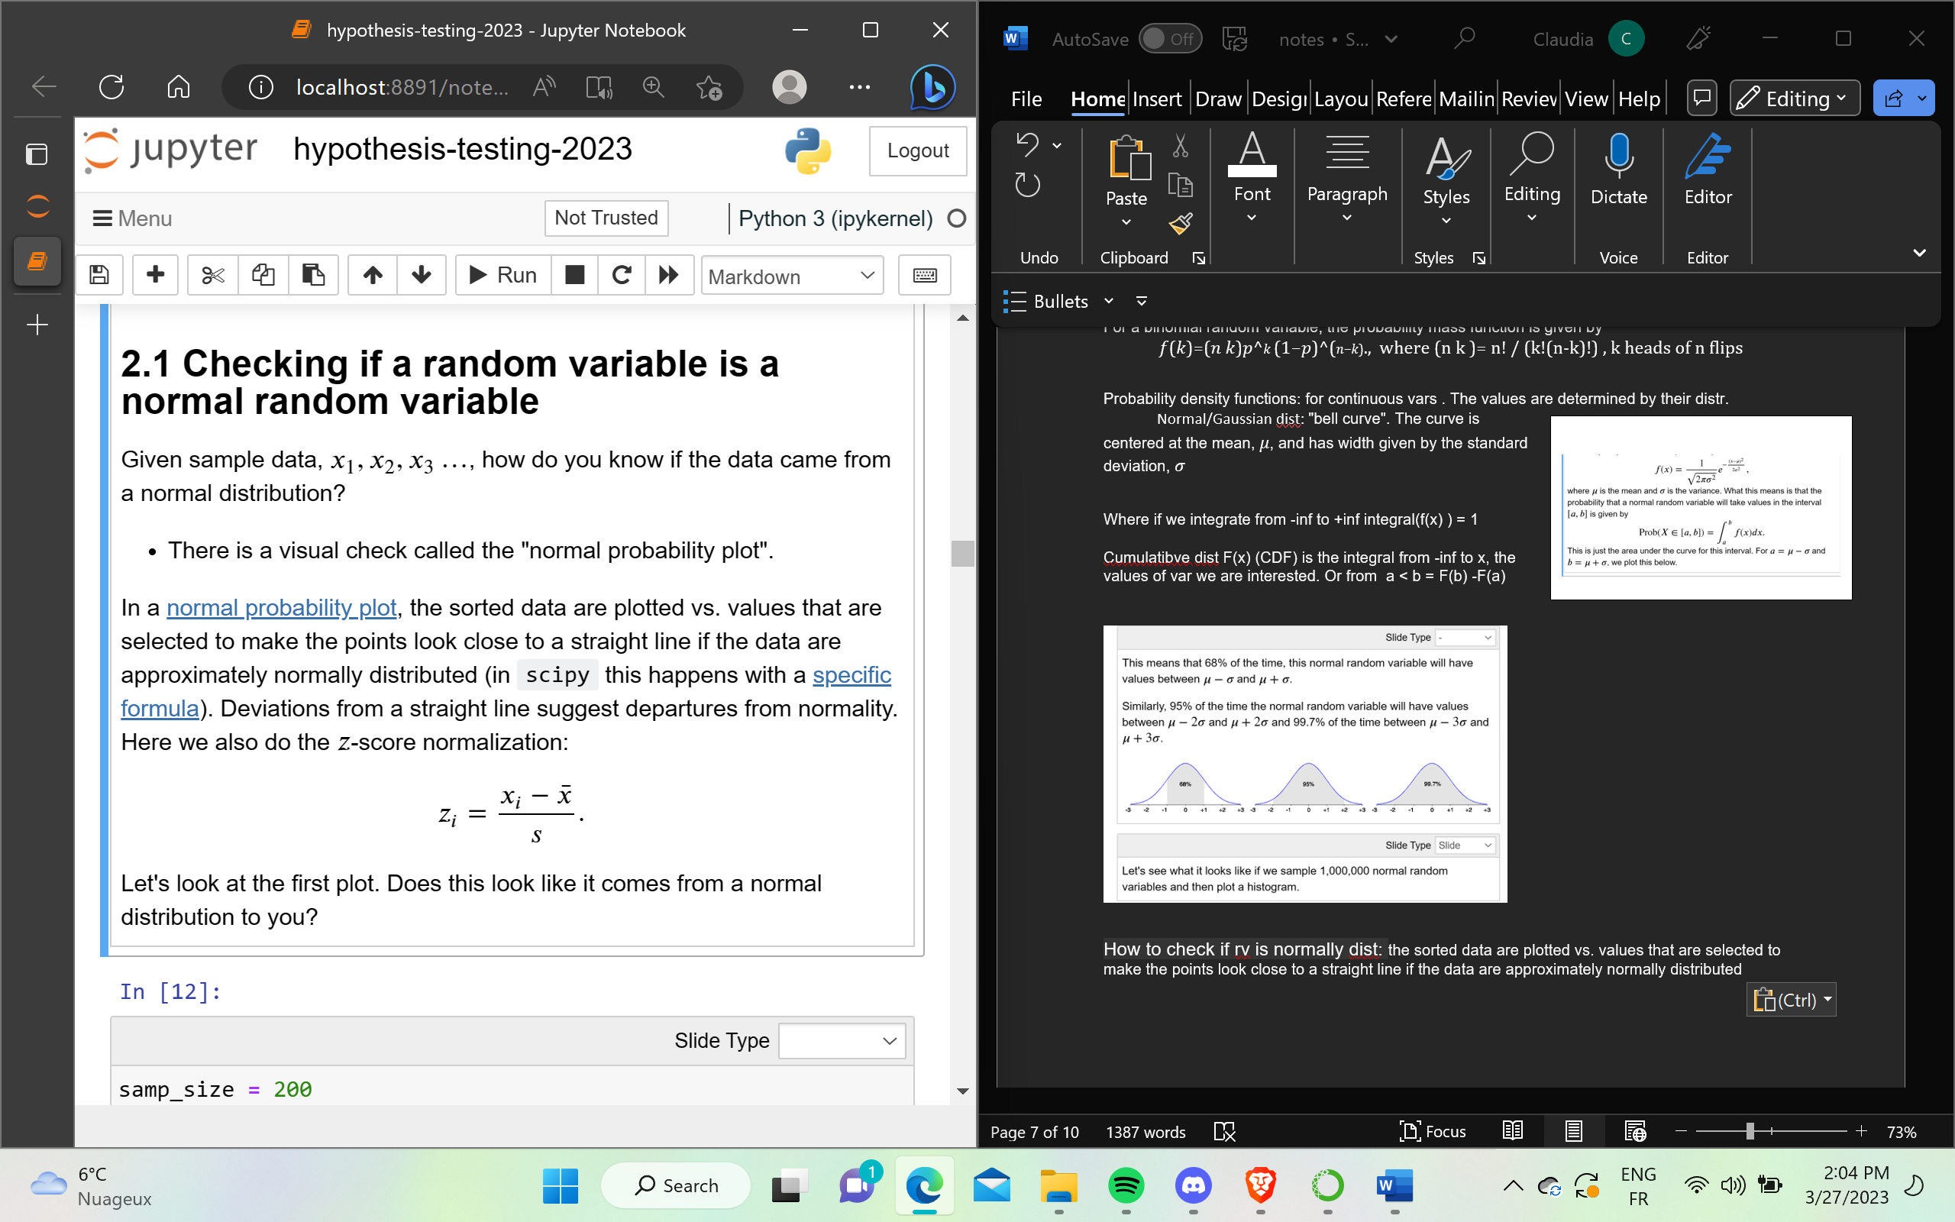

**Central Limit Theorem.** Let {𝑋1,…,𝑋𝑛} be a sample of 𝑛 random variables chosen identically and independently from a distribution with mean 𝜇 and finite variance 𝜎². If 𝑛 is 'large', then

the sum of the variables ∑ 𝑋𝑖 (until n) is also a random variable and is approximately **normally** distributed with mean 𝑛𝜇 and variance 𝑛𝜎²

* the mean of the variables 1/𝑛∑𝑋𝑖  is also a random variable and is approximately **normally** distributed with mean 𝜇 and variance 𝜎²/n

You also see why the normal distribution is **so important**. CLT tells us that if 𝑛 is large, binomial random variables will be distributed approximately normally

How many heads do we expect to see in a fair coin?

The CLT says that the number of heads (= sum of Bernoulli r.v. = binomial r.v.) is approximately normally distributed with mean

𝑛𝜇=𝑛𝑝=1000∗0.5=500

and variance

𝑛𝜎²=𝑛𝑝(1−𝑝)=1000∗0.5∗0.5=250.

Hypothesis Testing:

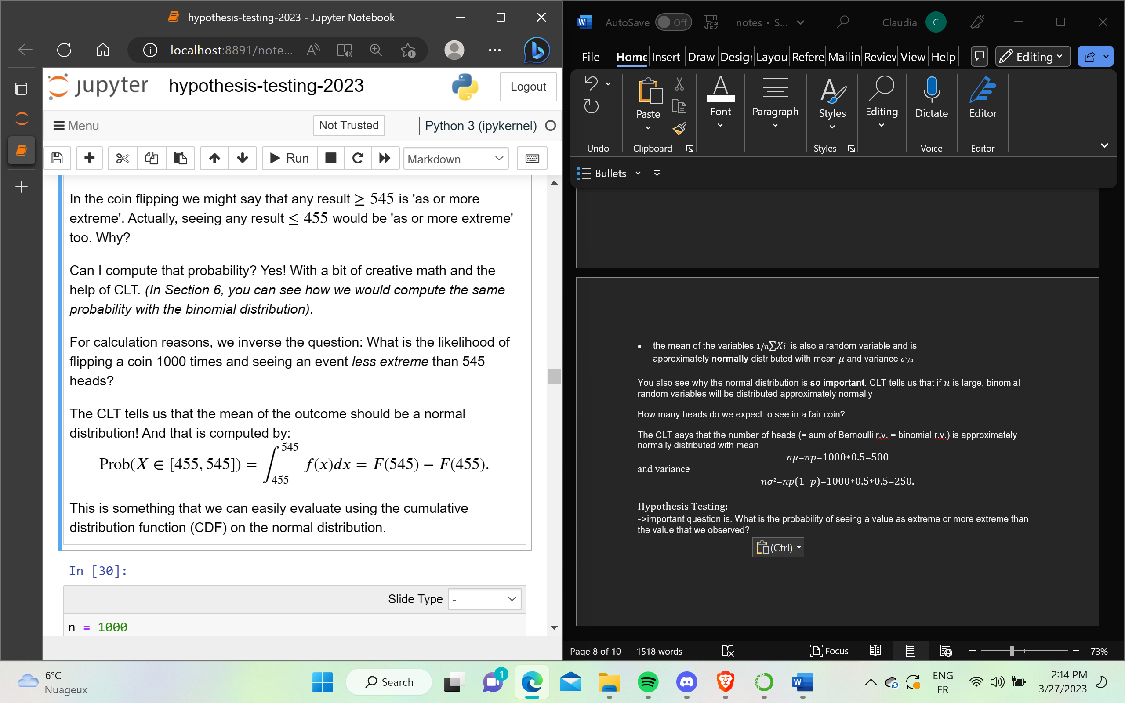

->important question is: What is the probability of seeing a value as extreme or more extreme than the value that we observed?



The p-value is a probability of observing an event as extreme as the one we did, assuming the null hypothesis to be true

The smaller p the stronger evidence against H0

If p< alpha; reject H0!

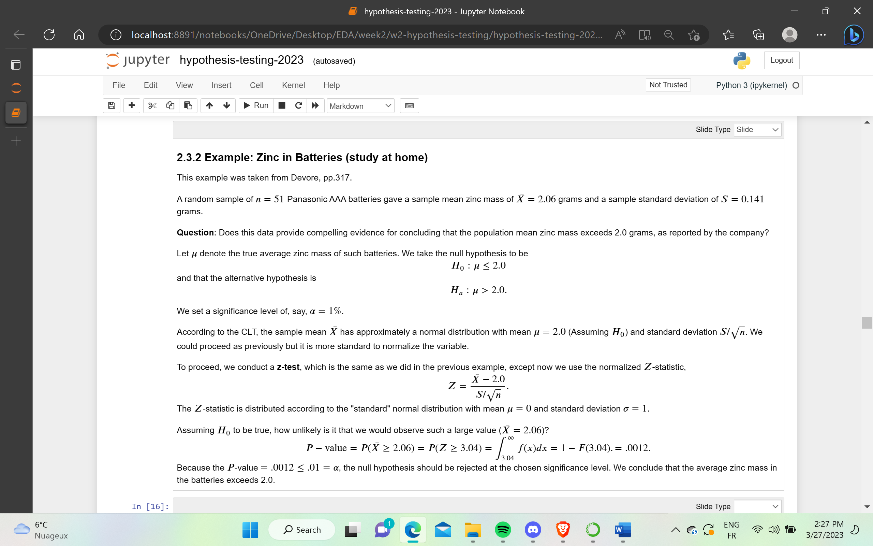

Hypothesis testing summary:

1.Identify the parameter of interest and describe it in the context of the problem.

Determine the null and alternative hypotheses.

Choose a significance level 𝛼

Find the formula for the computed value of the test statistic, e.g., 𝑍=(𝑋−𝜇)/(𝜎/sqr(n)) (use the CLT).

Using the sampled data, compute the 𝑃-value, e.g., 𝐹(𝑧)

Compare the significance level to the 𝑃-value to decide whether or not the null hypothesis should be rejected and state the conclusion in the problem context. Report the 𝑃-value!

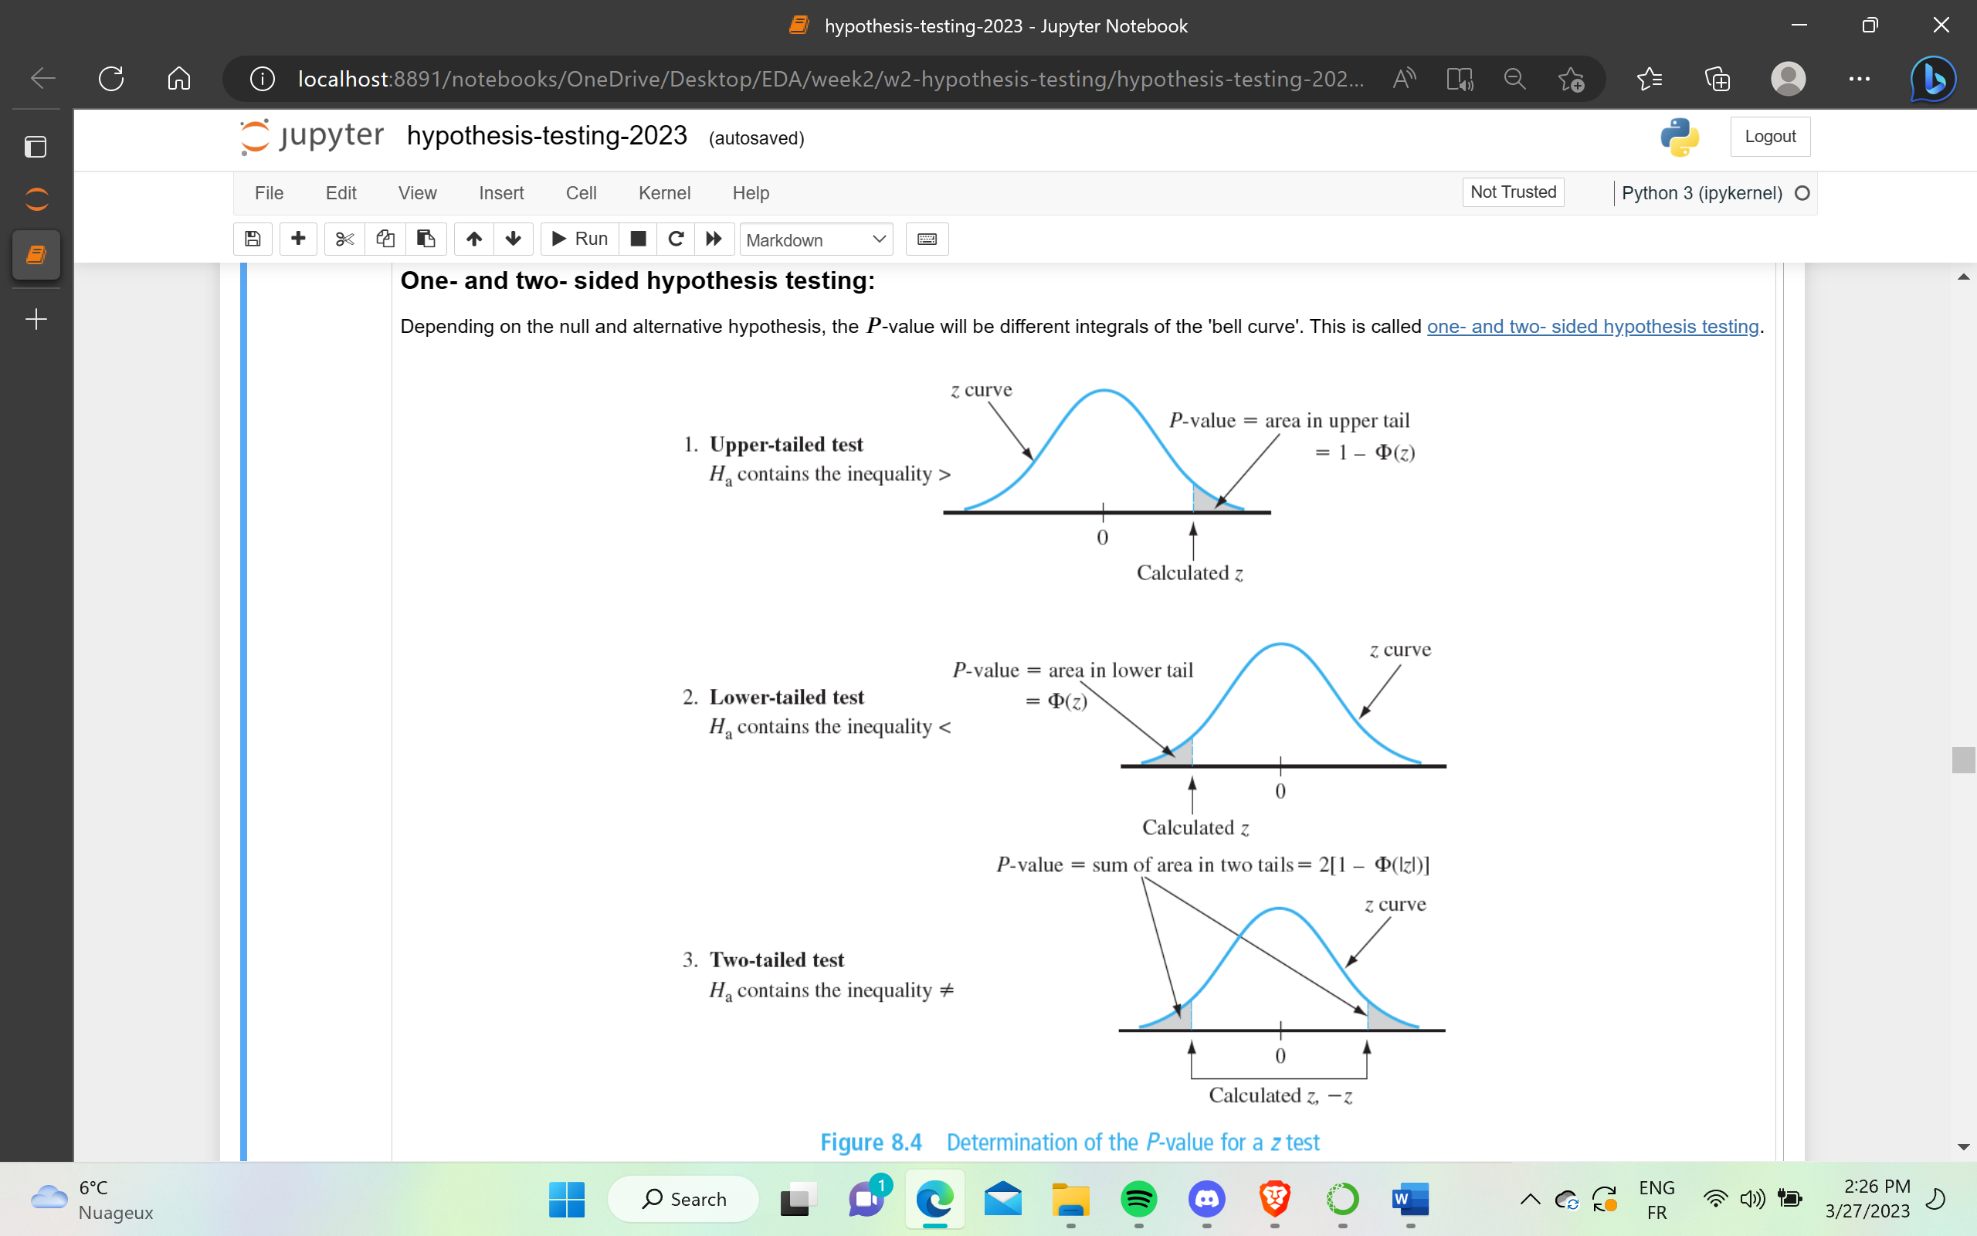

What if n is small? CLT cant be used.  if the samples are drawn from an approximately normal distribution, then the correct distribution to use is called the [Student's t- distribution](https://en.wikipedia.org/wiki/Student%27s_t-distribution) with 𝜈=𝑛−1 degrees of freedom. The student's t distribution has "heavier tails" than thenormal distribution. For a sample size greater than ≈20, the normality assumption is accepted.

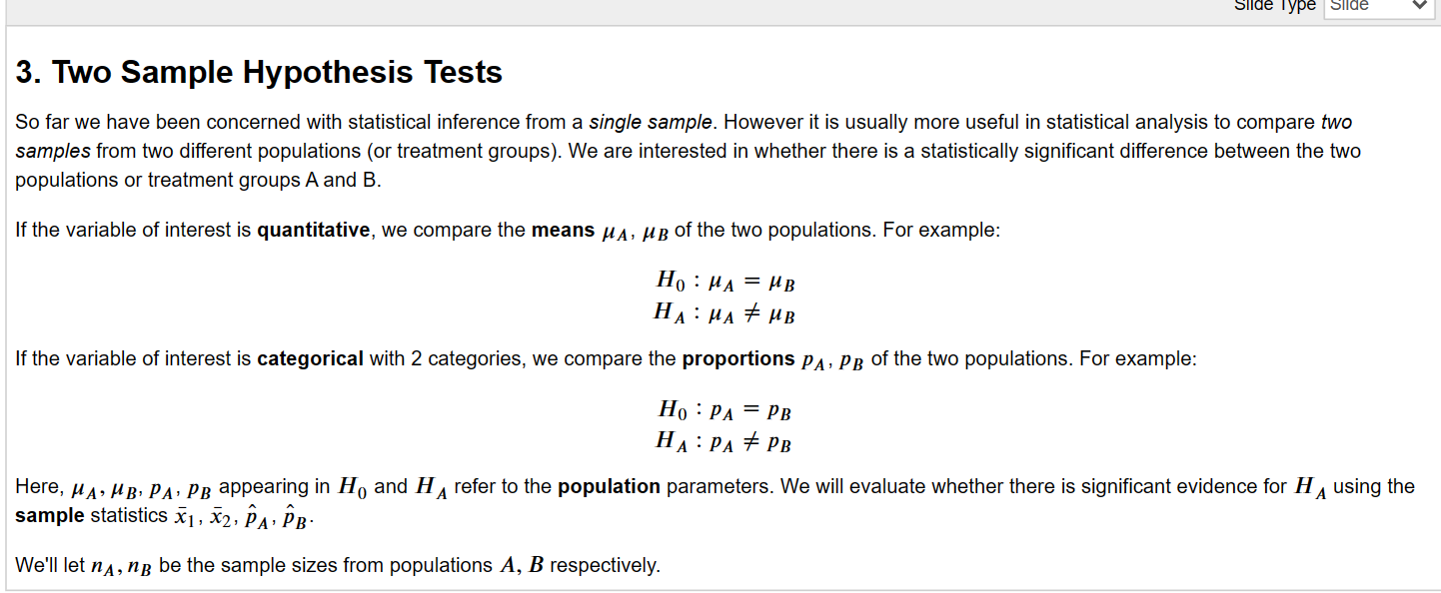

Compare with t-test (more robust than z-test)

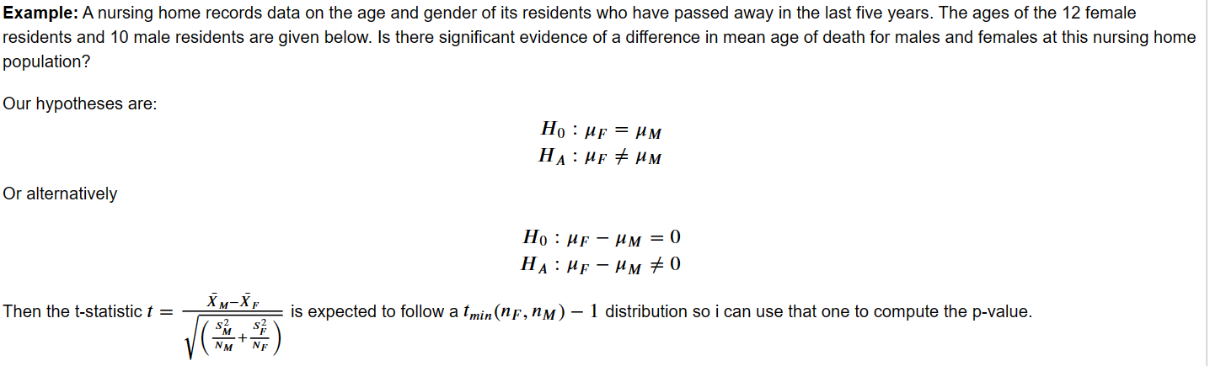

If we wanted to run a one-sided test (𝐻𝐴:𝜇𝐹>𝜇𝑀), then we would just cut in half the two-sided 𝑝-value.

2 independent samples of a binary categorical variable, we compare the proportions (i.e. percents) with a two sample 𝑧-test

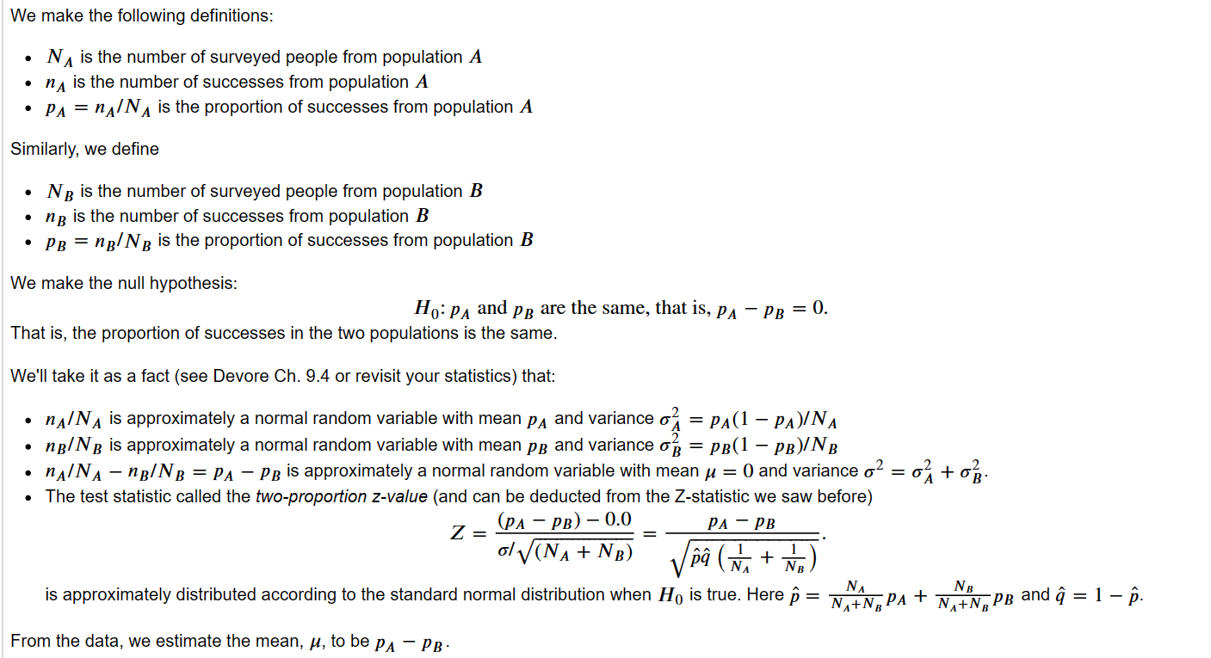

COMMON STATS TEST

The classical approaches are typically parametric, based on some underlying distributional assumptions of the individual data, and work well for large n (or if those assumptions are actually true).

The alternative approaches would be non-parametric in that there is no assumption of an underlying distribution, but they have slightly less power and may take more time & care to calculate. We do not cover them here

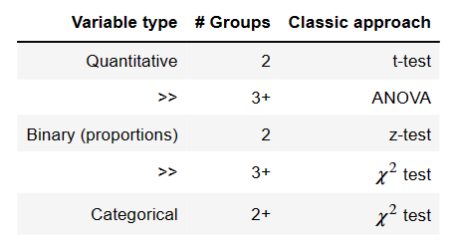

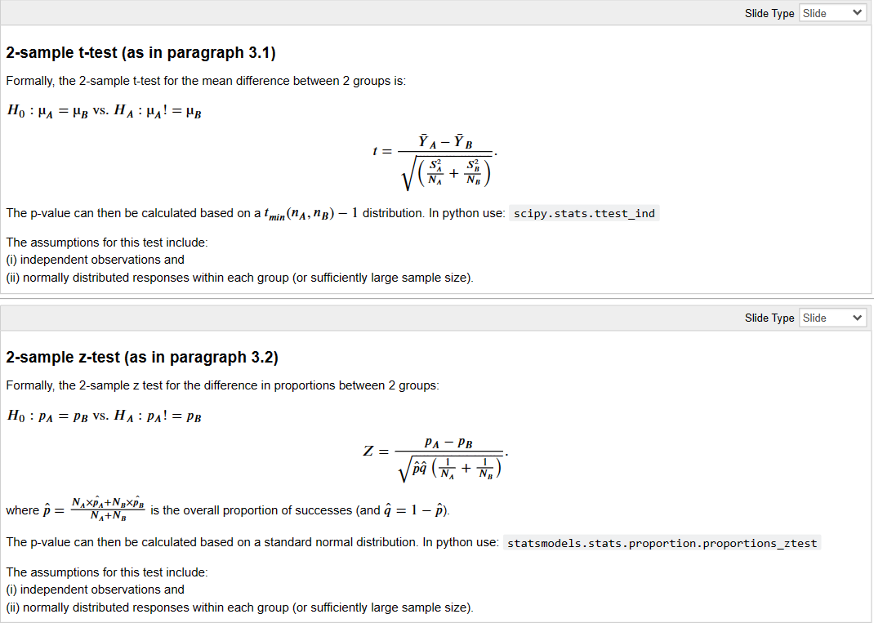



INDEPENDENCE FOR CATEGORICAL VALUES

categorical variable is different between 2 or more groups is the 𝜒² test for independence

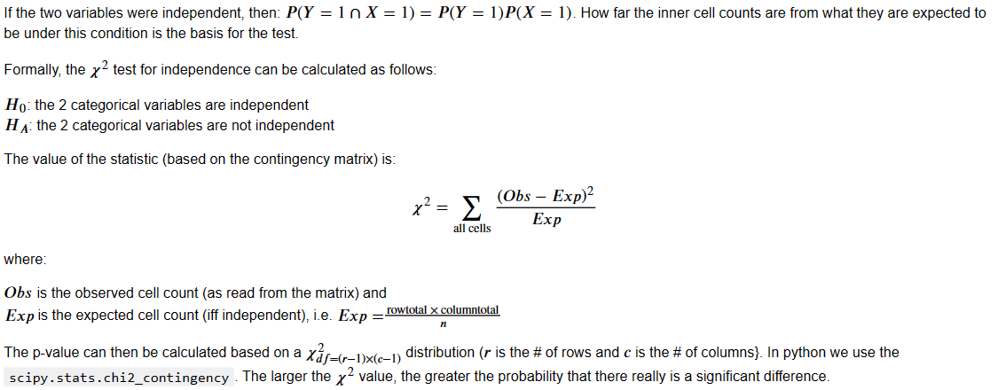

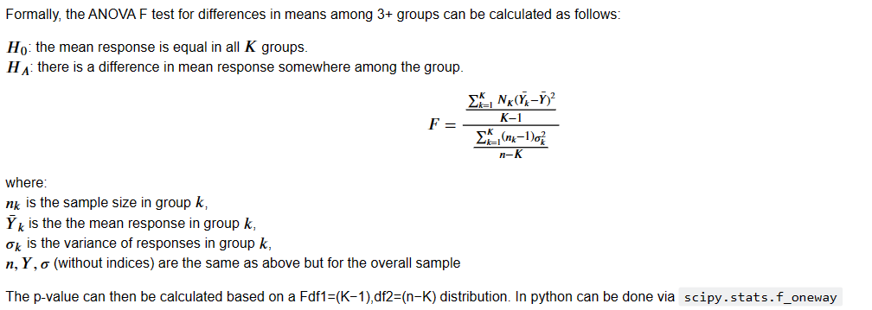

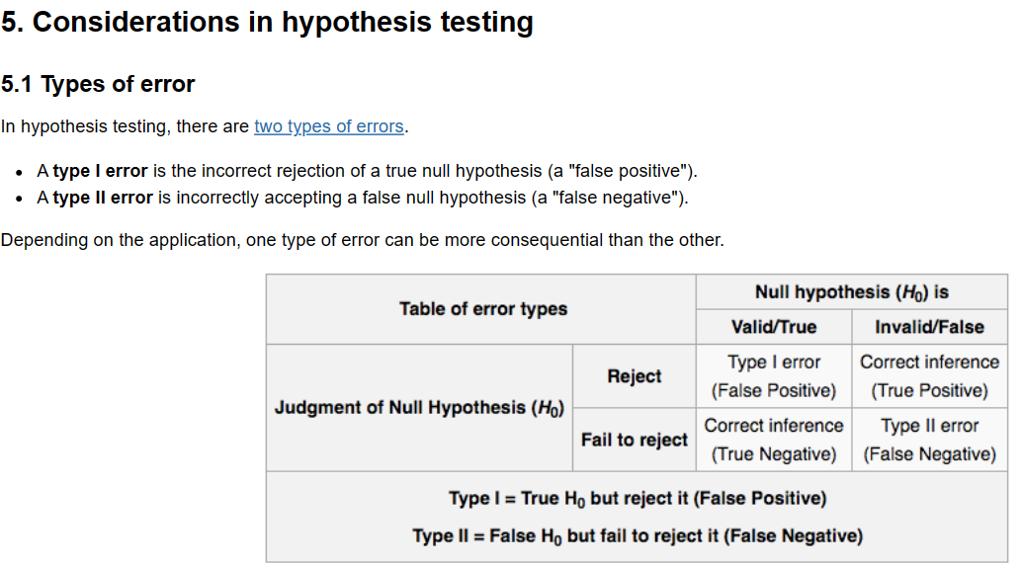

The probability of making a type I (false positive) error is the significance level 𝛼.

The probability of making a type II (false negative) error is more difficult to calculate.

Type 1: man is pregnant, type 2: pregnant woman is not pregnant

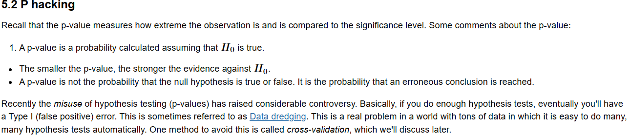

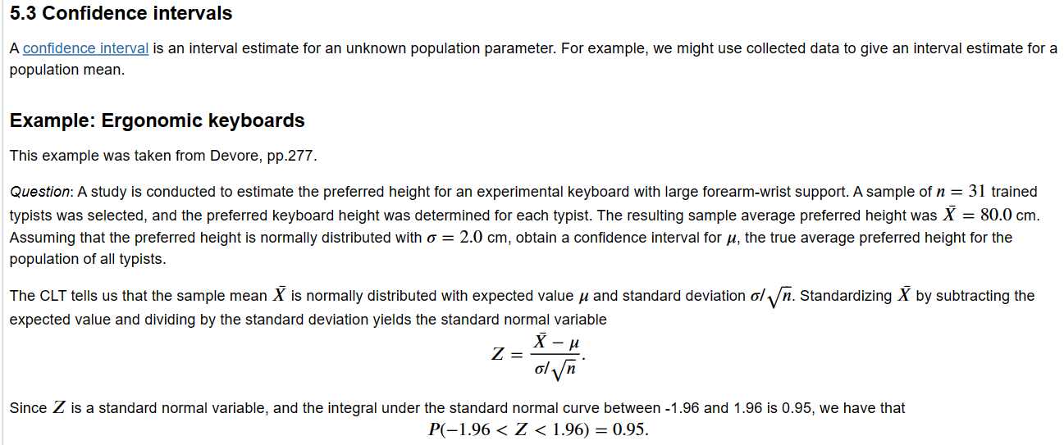

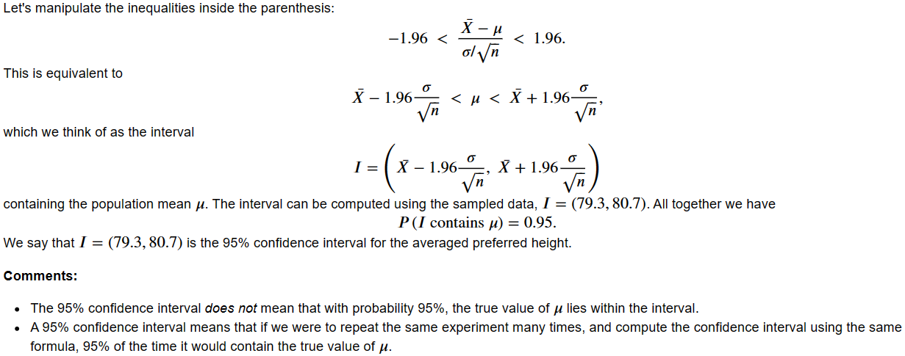LECTURE 3: LINEAR REGRESSION



Model : idealized representation of a system. To understand phenomena and make accurate preductions of unseen data

Loss function: metric of how “good” or “bad” our predictions are, from single observations. Loss function characterizes the cost, error, or fit resulting from a particular choice of model or model parameters.if y_pred -y_actual is close then low loss. The choice of luss function affects accuracy and computation cost of estimation. Depends on the prediction task: -outputs qualitative or quantitative. – all errors equally costly? (FN in cancer)

Care of entire DS not single obs. Take average loss (empirical risk) forall points = how well it fits given the data. Min average loss to best predict data.

Function is min when derivative = 0, do partial derivatives and find minima, double check with PDF

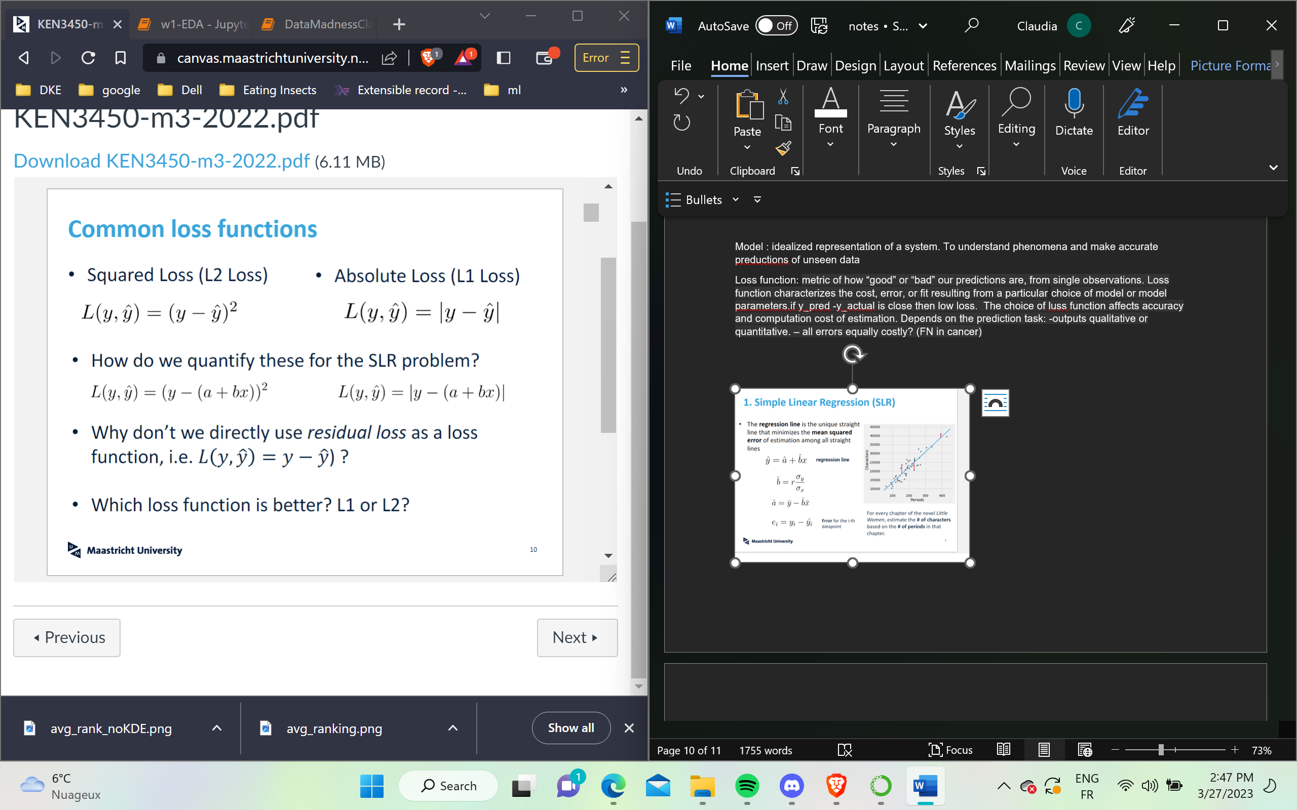

Performance measures: R2 , Sum of Squared Residuals (SSR) or Mean Square Error (MSE) or Root Mean Squared Error (RMSE). Lower -> more accurate

Checking for a good linear model: check linearity by plotand compute corr. Check residuals plot r = ^y – y for error. Check data bc outliers will affect the model.

SSR measures the amount of variability left unexplained after the linear regression. TSS measures the total variance in the data.  The benefit of the 𝑅² value over the SSR, between 0 or 1, so easier to interpret a good value. The % of total variance. For LR, R² == corr²;

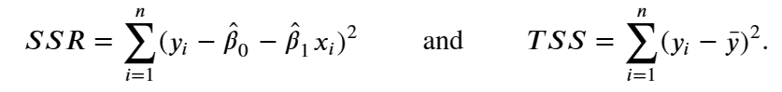

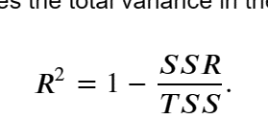

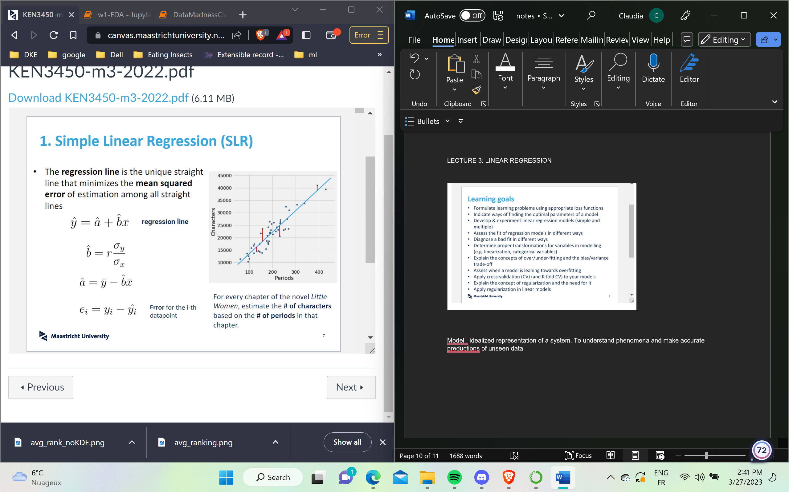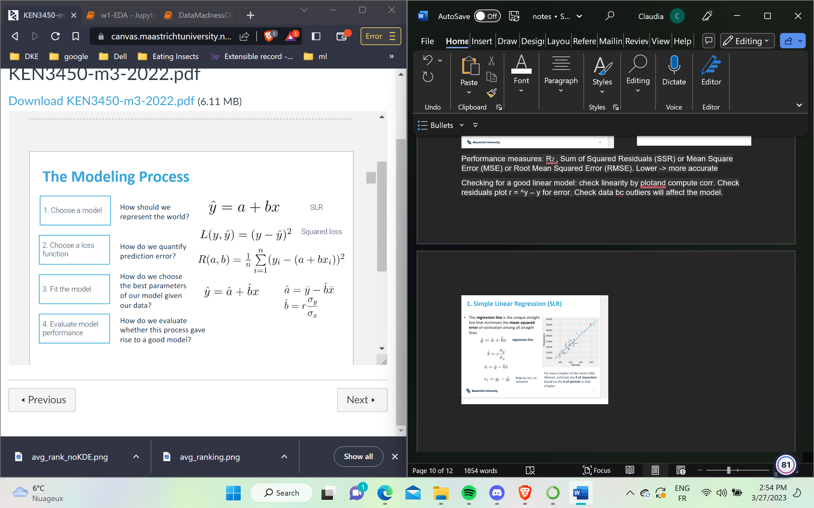

The intercept a. tells us without any adverstisemnt, a unit will be sold. B tells us how much per increase in x, y increases.

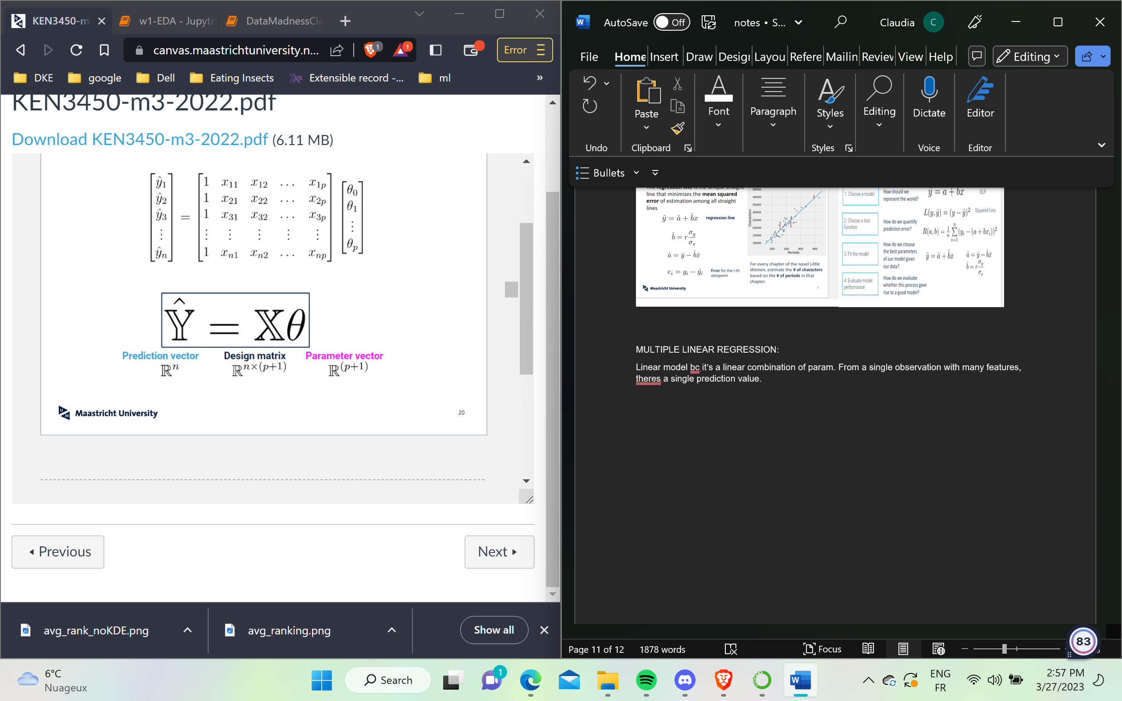

MULTIPLE LINEAR REGRESSION:

Linear model bc it’s a linear combination of param. From a single observation with many features, theres a single prediction value.

Min cost f. gets complex; look for numerical methods that approx. thebest param. Ex: gradient descent.



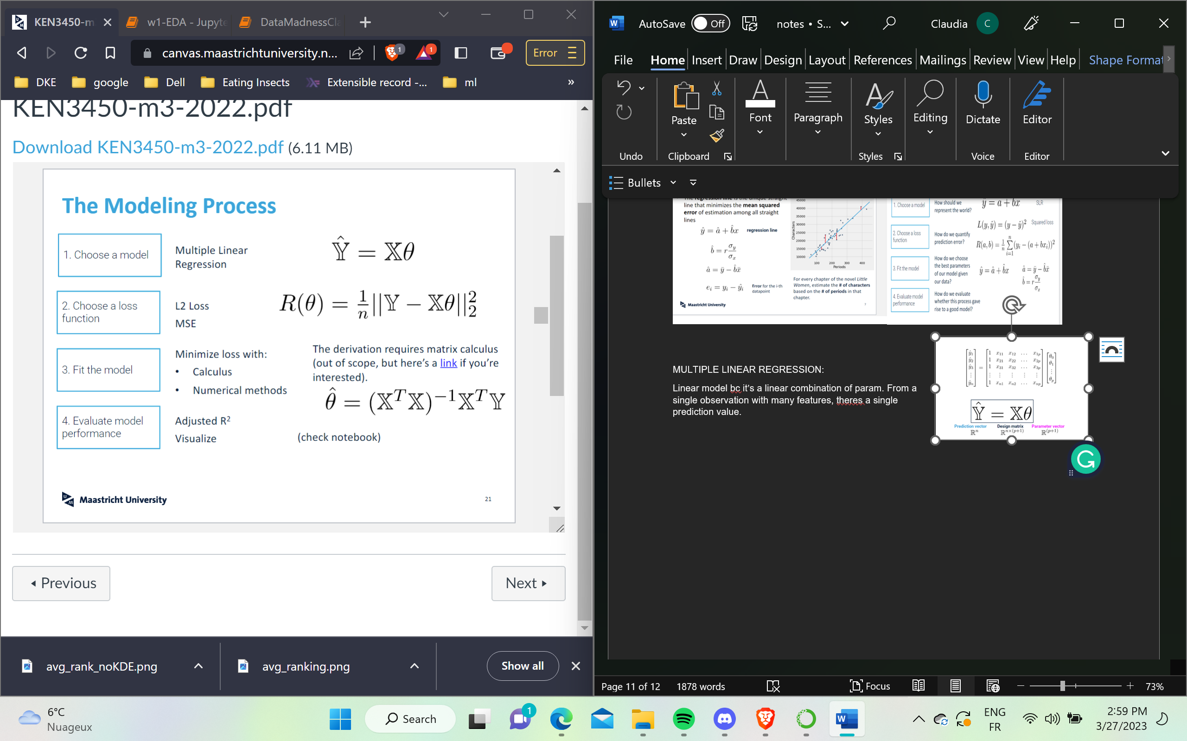

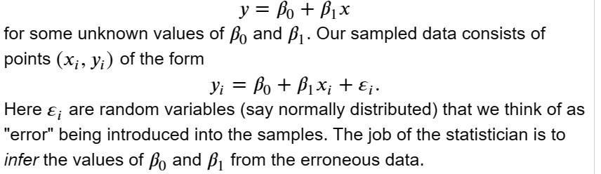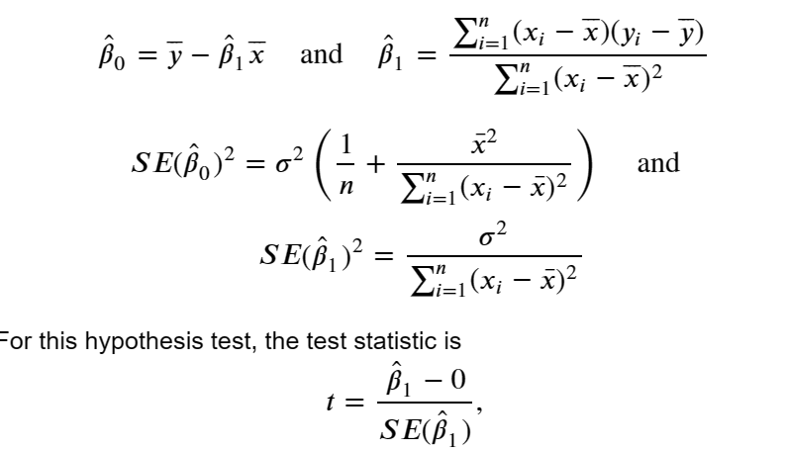

which under the assumptions of the null hypothesis, is distributed according to the 𝑡 distribution with 𝑛−2 degrees of freedom. The 𝑝-value is computed as the probability of observing a value as extreme as |𝑡|. A small 𝑝-value is interpreted to mean that there is an association between the independent and dependent variables.

When we estimate the variance of ε, we assume that the residuals (𝑒𝑖=𝑦𝑖−𝑦̂) are uncorrelated and normally distributed with mean 0 and fixed variance. Verify assumptions

In residual analysis, we typically create two types of plots:

* a plot of 𝑒𝑖  with respect to 𝑥𝑖. This allows us to compare the distribution of the noise at different values of 𝑥𝑖
* a histogram of 𝑒𝑖. This allows us to explore the distribution of the noise independent of 𝑥𝑖, or a plot of 𝑒𝑖 with respect to fitted values (𝑦𝑖)

Standard Errors assume that the covariance matrix of the errors is correctly specified.

TIME SERIES

Can be discrete in days, months

Continuous with sensor data .

There will exist some correlation between the instance at time taken and value. Time series, are measurmenets over time =, they are by nature correlated

We want the timeserires to be drawn from rv of gassian dist with mean and std

Stationarity is the assumption that the**statistics you calculate are the same** regardless of which way you sliced the data., such is not the case with ts; there are som trends , seasonalities. We can decompose the model into

X = trend + sesonal+ stationary